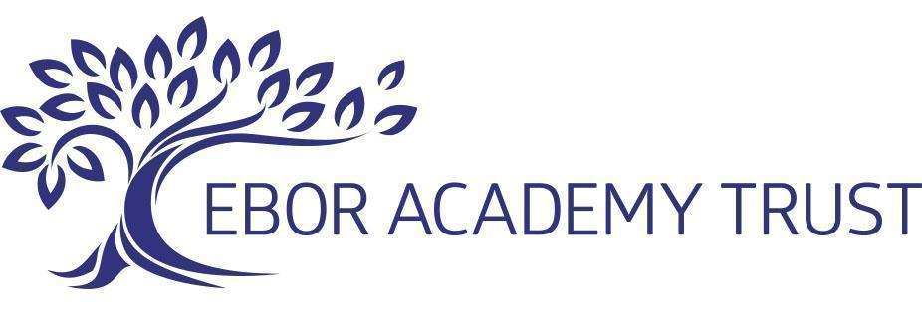

GDPR General Privacy Notice (19g)

Monitoring and Review of this Document:
The Trust shall be responsible for reviewing this document from time to time to ensure that it meets legal requirements and reflects best practice

Privacy Notice Introduction

This privacy notice has been written to inform individuals who come into contact with or visit Ebor Academy Trust about how and why we process your personal data. It includes when we process information relating to general queries, school admissions and complaints.
This privacy notice supplements the school’s other notices for pupils and parents, the workforce, and governors and volunteers.

Who are we?

Your school is part of Ebor Academy Trust, the ‘Data Controller’ ultimately responsible for how the school handles your personal information. This means that we determine the purposes for which, and the manner of the processing. We will only collect and use your personal data in ways which are compliant with data protection legislation.

Data Protection Officer (DPO): Wendy Harrington

The role of the DPO is to monitor our compliance with the UK GDPR and the Data Protection Act 2018 and advise on data protection issues. If you would like to discuss this privacy notice or our use of your data, please contact us:
dpo@ebor.academy

Ebor Academy Trust, The Leyes, York, YO10 3PR

Phone: 01904 806806

What personal information do we collect?
The personal data we collect about you will be dependent on the nature of your contact and relationship with us, but could include:

- Personal details, including name, address and contact information.
- Company details and contact information, if appropriate.
- Details of the reasons for contact with the school, and any communication preferences.
- Visitor information, such as the purpose of your visit and time you enter and leave the school, car registration number and any health conditions or disability access needs you tell us about.
- Photographs or video images, including CCTV footage where installed, if you visit the school site or attend school events.
- Records of communications and interactions we have with you, including telephone call recordings.
- Any details provided by yourself or third parties relating to a complaint investigation, including witness statements and interview notes.
- Information required for the school admissions process. This includes:
o Identifiers and contact details
o Reasons for the application
o SEN and/or Looked After status and history
o Relevant safeguarding information and professional involvement
o Equality information, such as ethnicity and gender.
o Characteristics including free school meal eligibility and language spoken
o Name of current and any previous school(s)
o Previous educational and assessment attainments

Under Article 9 of the GDPR, we may also collect, store and use information about you that falls into "special categories" of more sensitive personal data. This includes information about (where applicable):
- Characteristics, such as race, ethnicity, religious beliefs, sexual orientation and eligibility for certain benefits.
- Medical information (such as doctors’ information, child physical and mental health, dental health, allergies, medication, dietary requirements and details of isolation during a pandemic).
- CCTV and school entry systems images captured in school
- For faith schools: Information about your religion, as part of our admissions arrangements

Why do we need your personal data?

We process pupil and parent information for the purposes outlined below:
• To effectively respond to your query or request.
• To comply with a legal or regulatory obligation such as safeguarding and health and safety requirements.
• To process feedback and improve our services.
• To promote the school, including in newsletters, on the school website and social media platforms.
• To effectively administer the school’s complaints process.
• To effectively administer the school admissions process and maintain a waiting list if the child is not allocated a school place.
• To consider school admissions appeals.
• To monitor and inform our policies on equality and diversity.

What is our lawful basis for processing your information?
We only collect and use your personal data when the law allows us to.
Most commonly, we process data where:
- We need to comply with a legal obligation - Article 6(1)(c)
- We need it to perform an official task in the public interest - Article 6(1)(e)
- We need it to perform a contract - Article 6(1)(b)

Less commonly, we may also process personal data in situations where:
- We have obtained consent to use it in a certain way - Article 6(1)(a)
- We need to protect the individual’s vital interests - Article 6(1)(d)
- Legitimate interests - Article 6(1)(f)

Where we are processing your personal data with your consent you have the right to withdraw that consent. If you change your mind or are unhappy with our use of your personal data, please let us know by contacting dpo@ebor.academy.

Some of the information we collect about you is classed as special category data under the UK GDPR. The additional conditions that allow for processing this data are:

- Article 9(2)(a) - explicit consent
- Article 9(2)(g) - reasons of substantial public interest (with a basis in law)
- Article 9(2)(c) - we need to protect an individual’s vital interests (i.e. protect your life)
- Article 9(2)(f) - we need to process it for the establishment, exercise or defence of legal claims
- Article 9(2)(i) - public health (with a basis in law)

The applicable substantial public interest conditions in Schedule 1 of the Data Protection Act 2018 are:

- Condition 6 - statutory and government purposes
- Condition 8 - equality of opportunity or treatment
- Condition 10 - preventing or detecting unlawful acts
- Condition 18 - safeguarding of children and vulnerable people

Who do we obtain your information from?

We normally receive this information directly from you. However, we may also receive some information from the following third parties:

- Department for Education (DfE).
- Local Authority.
- Other agencies working with the child/family, such as Police, Health Services etc.
- A child’s previous school.
- Ofsted.

How long do we keep your personal data for?

We keep personal information about you while your child is attending our school. We may also keep it beyond their attendance at our school if this is necessary in order to comply with our legal obligations. A copy of this document can be found on the school’s website.

We have put in place appropriate security measures to prevent your personal information being accidentally lost, used or accessed in an unauthorised way, altered or disclosed.

We will dispose of your personal data securely when we no longer need it.

We may also retain some information for historical and archiving purposes in accordance with our Records Management policy.

Who do we share your personal data with?
We do not share information about you with any third party without consent unless the law and our policies allow us to do so.

Where it is legally required, or necessary (and it complies with data protection law), we may share personal information about you with:

- other schools and academy trusts in the UK
- local authorities
- Government departments such as the Department for Education (DfE)
- Schools ICT and our IT suppliers
- Text and email communication systems
- PFI company (where the school buildings are owned by PFI)
- Door entry system providers (eg Inventry)
- FSM checker services
- Our regulator, eg Ofsted and DfE
- The Diocese and York District Board of Education
- Alternative education providers
- Insurance companies

International transfers of data
Although we are based in the UK, some of the digital information we hold may be stored on computer servers located outside the UK. Some of the IT applications we use may also transfer data outside the UK. Normally your information will not be transferred outside the European Economic Area, which is deemed to have adequate data protection standards by the UK government. In the event that your information is transferred outside the EEA, we will take reasonable steps to ensure your data is protected and appropriate safeguards are in place.

What rights do you have over your data?
Under the UK GDPR, individuals have the following rights in relation to the processing of their personal data:
- To be informed about how we process your personal data. This notice fulfils this obligation.
- To request a copy of the personal data we hold about you.
- To request that your personal data is amended if inaccurate or incomplete.
- To request that your personal data is erased where there is no compelling reason for its continued processing.
- To request that the processing of your personal data is restricted.
- To object to your personal data being processed.

If you have a concern about the way we are collecting or using your personal data, you should raise your concern with us. If we cannot resolve your concerns then you may also complain to the Information Commissioner’s Office at https://ico.org.uk/concerns/
For further information on how to request access to personal information held centrally by DfE, please see the ‘How Government uses your data’ section of this notice.

Withdrawal of consent and the right to lodge a complaint

Where we are processing your personal data with your consent, you have the right to withdraw that consent. We will make this clear when we ask for consent, and explain how consent can be withdrawn. If you change your mind, or you are unhappy with our use of your personal data, please let us know by contacting your school office or dpo@ebor.academy.

Last updated
We may need to update this privacy notice periodically so we recommend that you revisit this information from time to time. This version was last updated in November 2024.

Contact
If you would like to discuss anything in this privacy notice, please contact: Wendy Harrington, Data Protection Officer, Ebor Academy, The Leyes, Osbaldwick, York YO10 3PR via dpo@ebor.academy.

