Privacy Notice – Primary school pupils (KS1) 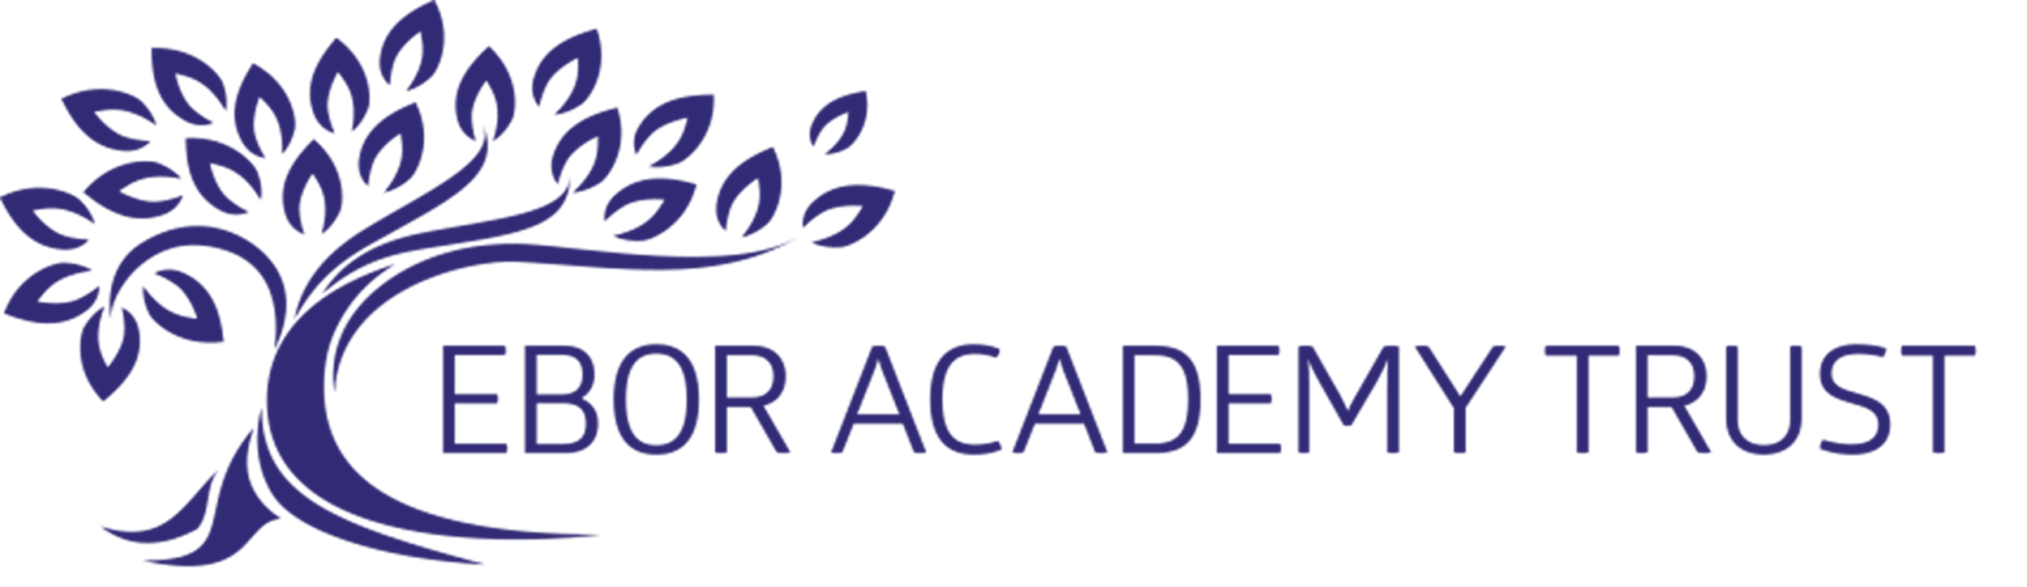

At school, we keep information about you safe, like treasure in a treasure chest!

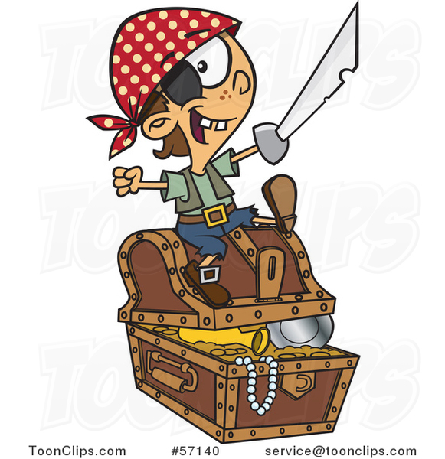
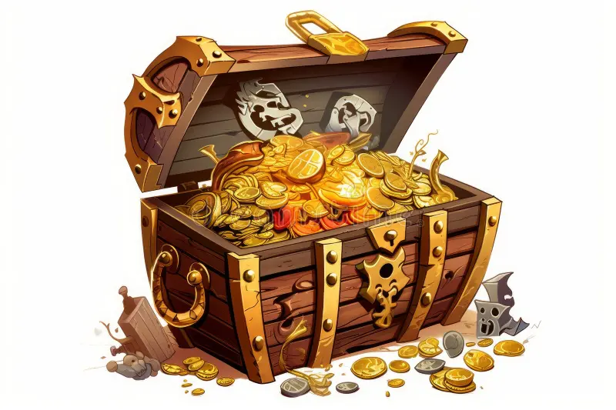
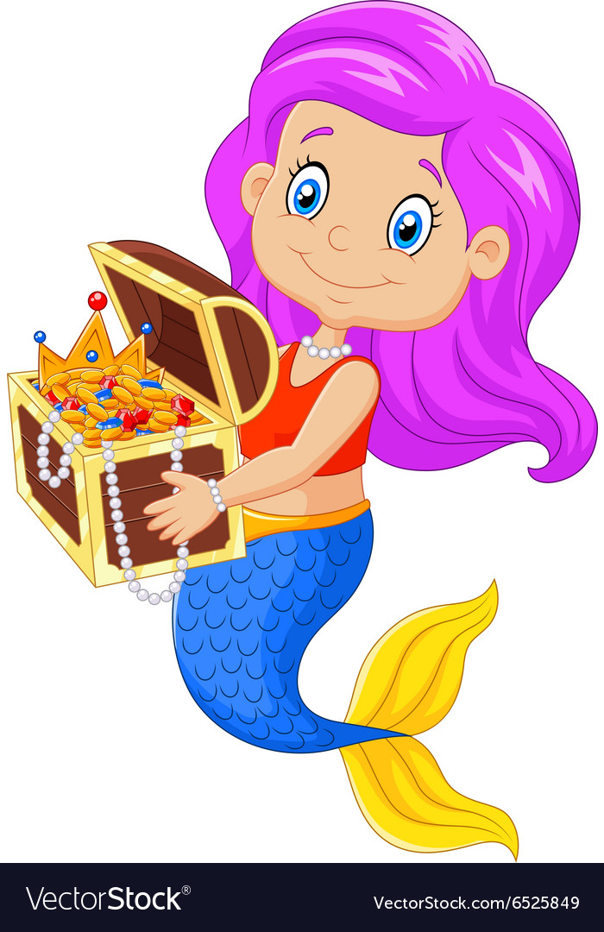

Only trusted adults like teachers, people who work in the school, parents and carers can see it.

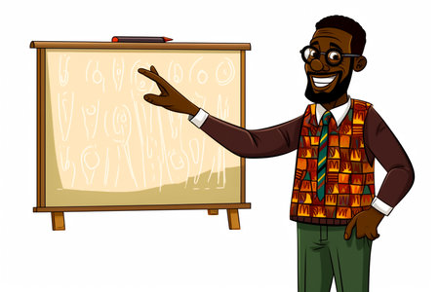
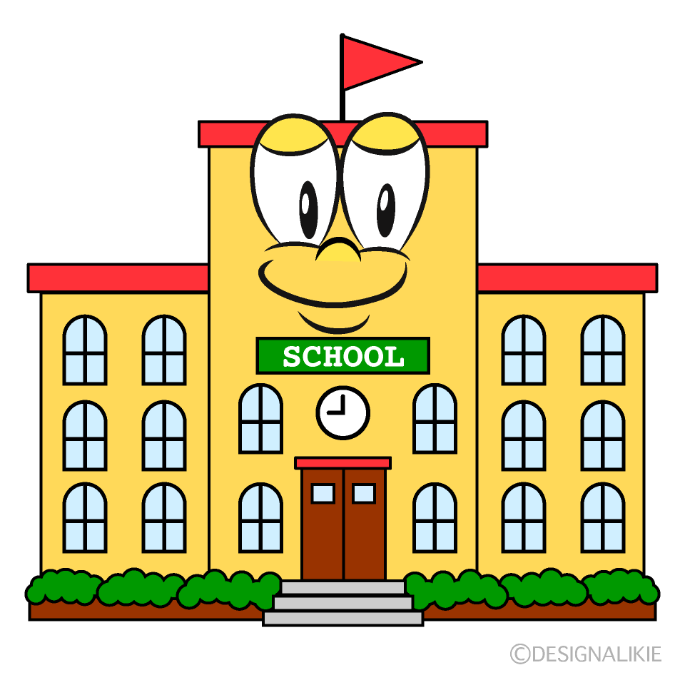
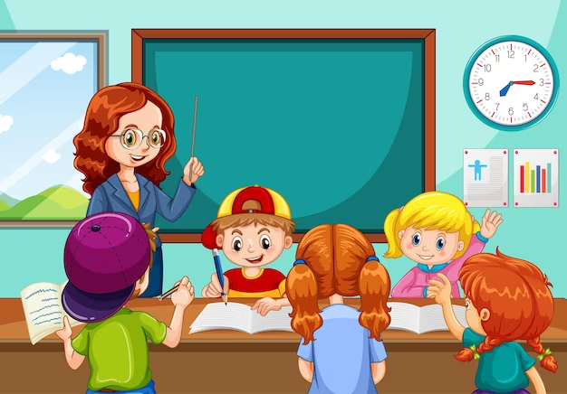

We keep information about you to keep you safe, keep you healthy and so we can contact your carers or parents.

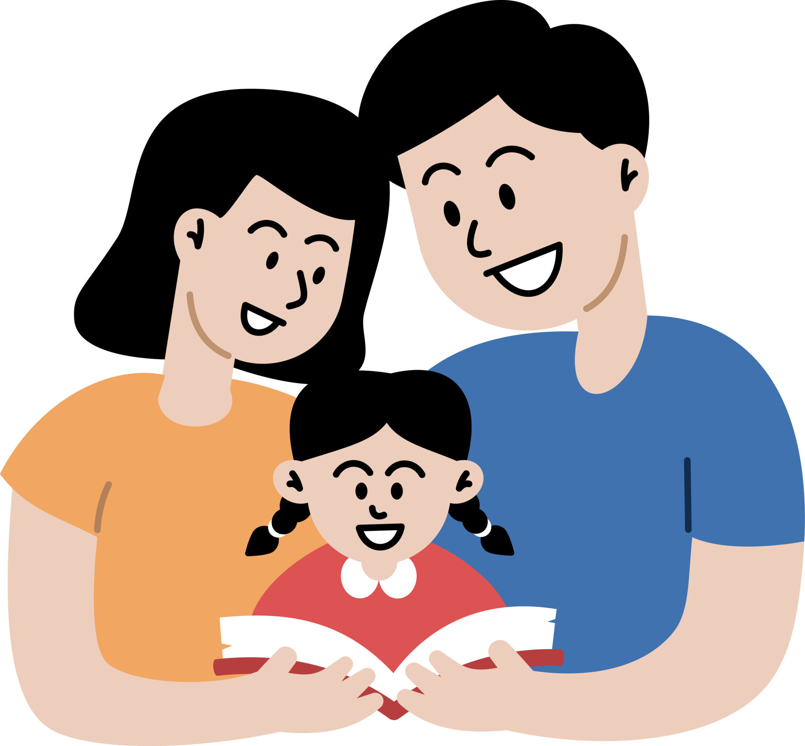
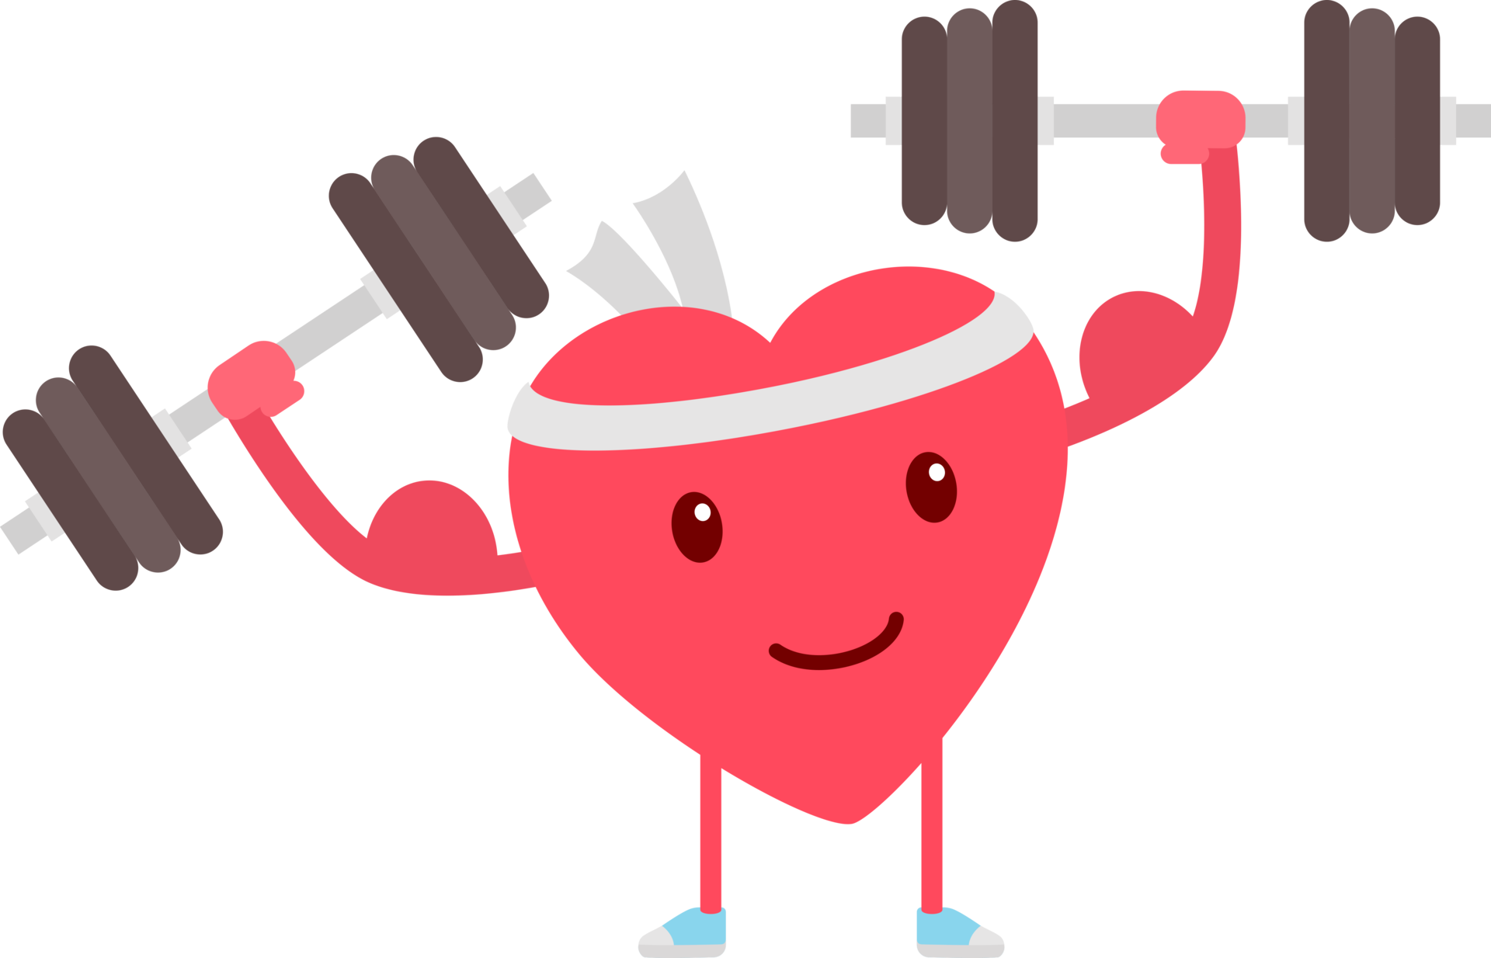

We get this information from you, your parents or carers, people who work in the school and important people outside the school like your doctor.

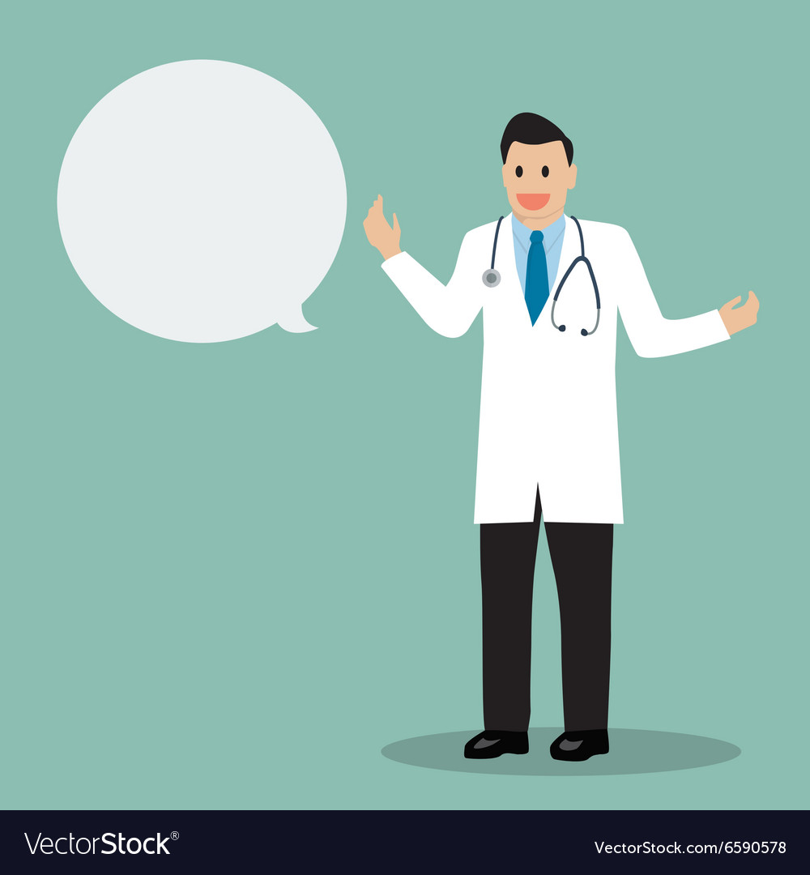
We keep this information until you leave the school

