**Ice, Ice Baby- Can anyone visit the South Pole?**

Our topic this term is all about the Polar Regions. In geography we will be locating the Polar Regions on a world map and learning about their geographical features. We will be comparing these Polar Regions to our local area Sigglesthorne. In history, we will learn about the explorers Robert Scott and Roald Amundsen and their great race to the South Pole.

**Science- Animals and their habitats**

In science, we will be learning about different animals. We will be classifying and sorting them based on different characteristics. We will look at arctic animals and how they adapt to survive. We will look at different habitats for animals and what makes them dead or alive.

**Squirrels**

Knowledge Organiser

Spring Term

‘Ice, Ice Baby’

**Key books**

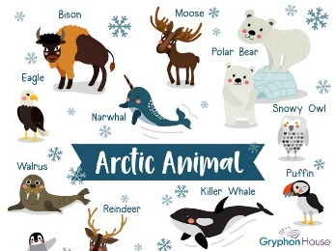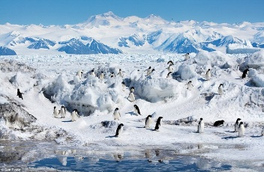

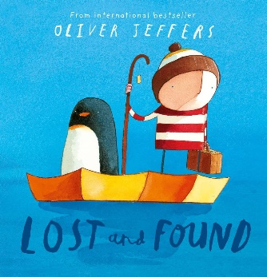

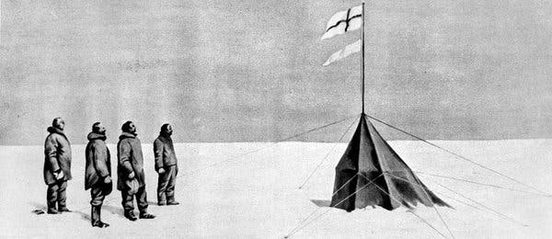

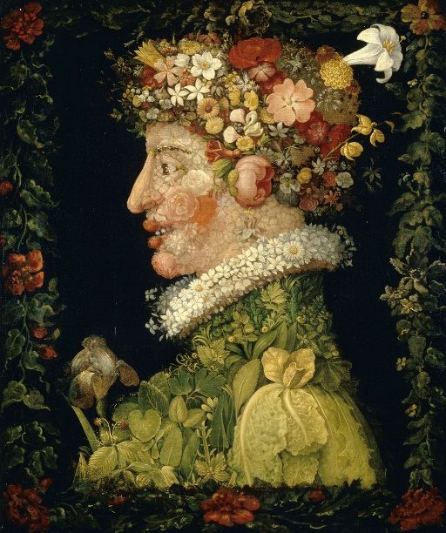

**Art**

This term we will be looking at the artist Giuseppe Arcimboldo and how he created portraits out of fruits, flowers, vegetables and meat according to the season.

**Maths**

We will continue to follow the NCETM mastery approach, building our knowledge and skills using concrete, pictorial and abstract approaches. We will be developing our addition and subtraction skills to include 2-digit numbers. This term we will also learn how to multiply and divide numbers using our 2, 3, 5 and 10 times tables.

We will begin the New Year with the lovely story ‘Lost & Found.’ We will learn about and explore the existing text, and use this to inspire us to create and write our very own stories. We will then move onto looking at non-chronological reports about polar animals. This will be supported by daily phonic and guided reading lessons.

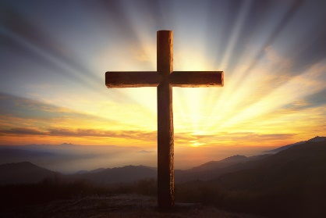

**RE**

Our lessons will link to the theme of ‘belief.’ We will be considering the differences between facts and beliefs and exploring the beliefs of faith members. We will look at the beliefs of Christians as well as our own personal beliefs and also begin to explore non-religious beliefs. We will have the opportunity to speak and ask questions to a faith member and to learn more about their commitment to their faith.



**Computing**In computing, we will learn how to use devices to take photographs. We will explore different angles and lighting and learn how to edit and modify these images. We will also be using a computer to create music. We will listen to a variety of pieces of music and consider how music can make us think and feel. We will compare creating music digitally and non-digitally and look at patterns to purposefully create music.

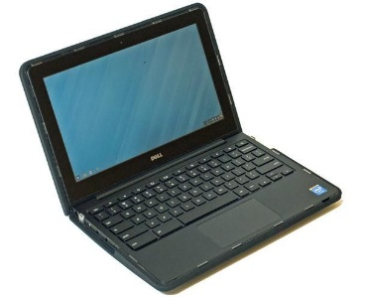

PE will continue to be on a Thursday and Friday afternoon.

Mrs Hunt will also teach music every Friday.

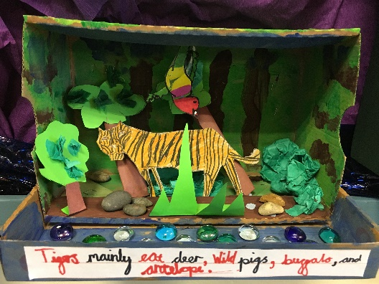

**PSHE**

Our PSHE lessons this term are all about ‘changes.’ We will begin by thinking about the many changes that happen throughout our lives. We will be discussing how these changes can make us feel and developing positive strategies to help us manage the many changes that life brings.

**DT**

Linking to our science topic, we will be creating our own shoebox habitats by joining a range of materials in different ways.