**Science- Materials**

Lessons will focus on identifying materials, grouping their uses, investigating their suitability for different uses, and changing the shape of materials. We will also be learning about recycling and scientists who discovered materials in the past such as Charles Macintosh. There will be many opportunities to develop scientific enquiry skills and lessons will also be linked to real-life jobs in the relevant industries.

**A Palace of Wonder**

Our topic this term is all about kings and queens. In history we will begin by looking at what a monarch is and learn more about our current queen, Elizabeth II. We will then learn about Queen Victoria and what life was like during the Victorian era comparing this to our lives today. In geography we will be learning about the United Kingdom and using our map skills to locate British castles.

**Squirrels**

Knowledge Organiser

Autumn Term

‘A Palace of Wonder’

**Key books**

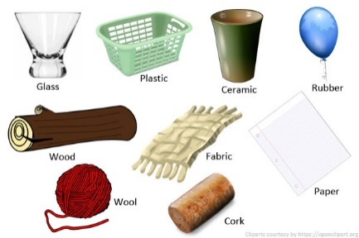

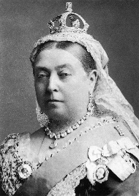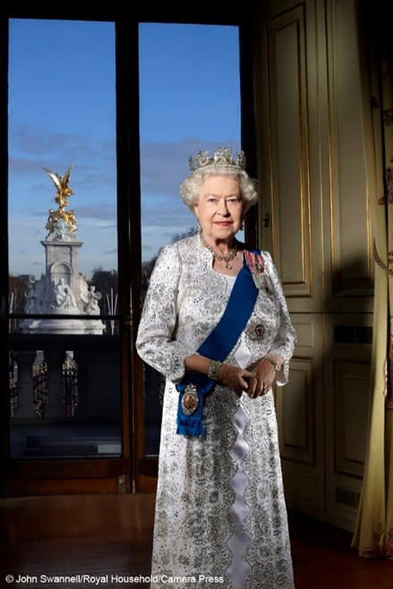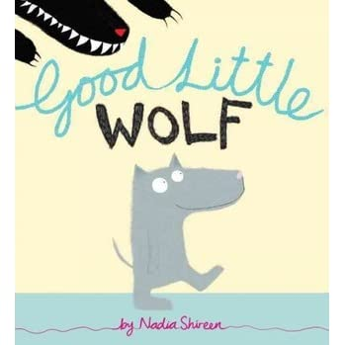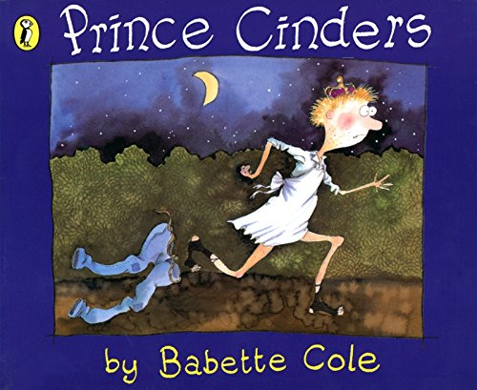

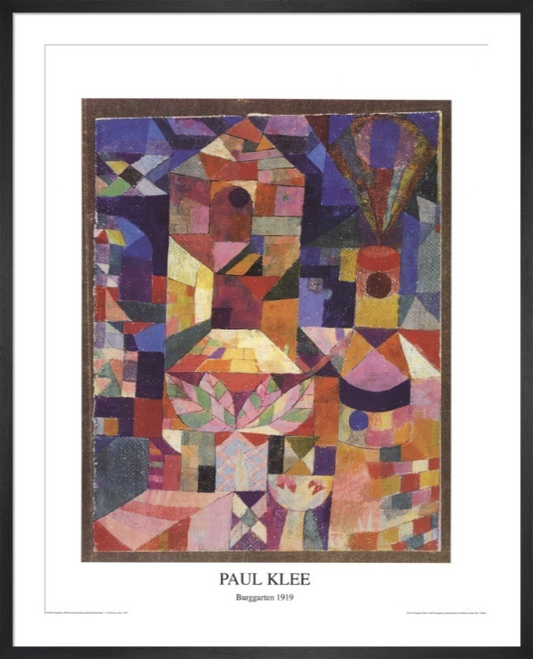

**Art**

Our art this term will focus on the artist Paul Klee. We will be looking at examples of his work and using these as inspiration for our own pieces of artwork.

**Maths**

We will continue to develop our fluency, reasoning and problem-solving skills focussing on place value, addition and subtraction. We will follow the NCETM mastery approach. We will build our knowledge and skills using concrete, pictorial and abstract approaches. This enables us to develop firm mathematical foundations.

We will begin this term by looking at traditional tales and alternative versions of these, linking to our theme of kings and queens. We will be sequencing the stories and using these to write our own stories. We will also be writing some autumn poems and recounts. This will be supported by daily phonic and guided reading lessons.



**RE**

Our lessons will link to the theme of ‘belonging’. The children will reflect upon their personal relationships and will consider what it means to belong. They will look at life within faith and what it means to people of faith to believe and belong. They will be reflective about their own relationships.



**Computing**

In computing this term, we will expand our digital literacy knowledge and skills. We will be exploring Information Technology and the importance of this in school and the wider world. We will be learning about how to stay safe online and the importance of keeping personal information private. The children will have opportunities to expand their computer skills and apply these in different lessons, including creating digital drawings of castles.

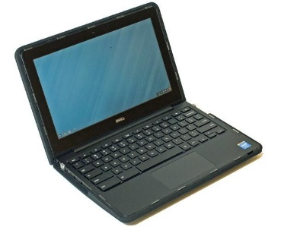

PE will be on a Thursday and Friday afternoon.

Mrs Hunt will also teach music every Friday.

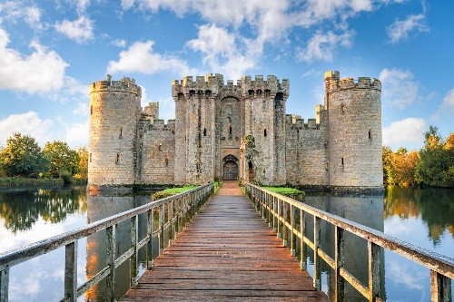

**PSHE**

We will be learning about keeping safe and healthy in PSHCE this term. We will explore the importance of physical, mental and emotional health. The children will also learn that household products, including medicines, can be harmful if not used properly. We will identify rules for keeping safe and recognise a shared responsibility for keeping ourselves and others safe.

**DT**

Linking to our theme, ‘A Palace of Wonder’, the children will increase their understanding of mechanical systems by designing and creating 3D castles with a lever door.