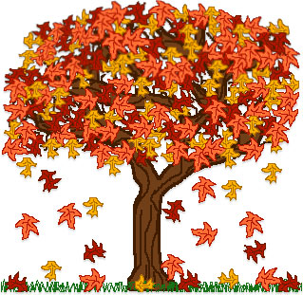https://images-na.ssl-images-amazon

RE

Our lessons this term will link to ‘beliefs and practices’ while we look at the significances of religious festivals and rituals. We will also explore how people express their beliefs through personal symbols and artefacts.

Team Foxes

Knowledge Organiser

Autumn Term

Science - Rocks

We will be looking at different types of rocks including sedimentary, igneous, metamorphic and human made. We will be investigating the properties of different rocks, while exploring different ways we can group them. We will be studying the work of Mary Anning, along with the formation of fossils!   
  
What are the different types of rock?  
What are they used for?

Key book this term

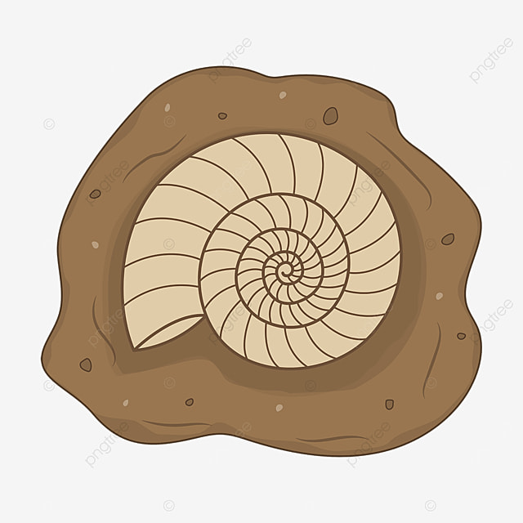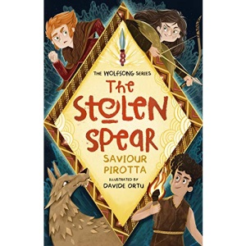

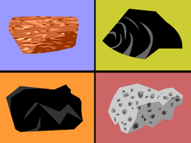

This term we will develop our literacy skills by looking at the book, The Stolen Spear. This book will support our development of non-chronological reports and poetry. This story will also support our work in writing our own diary entries and newspaper articles! We will also use various other literary sources to confirm our understanding of how to write a detailed set of instructions.   
  
Will we be able to write our own diary entries set in the Stone Age?



Vittorio Zunino Celotto/Getty Images

Maths

This term we are working on our abilities to add and subtract using the column method. Through this, we will develop our mental math capabilities.

We will also be using this information to work out the perimeter of a shape and identify some different angles.

Our work will also include work on our times tables!

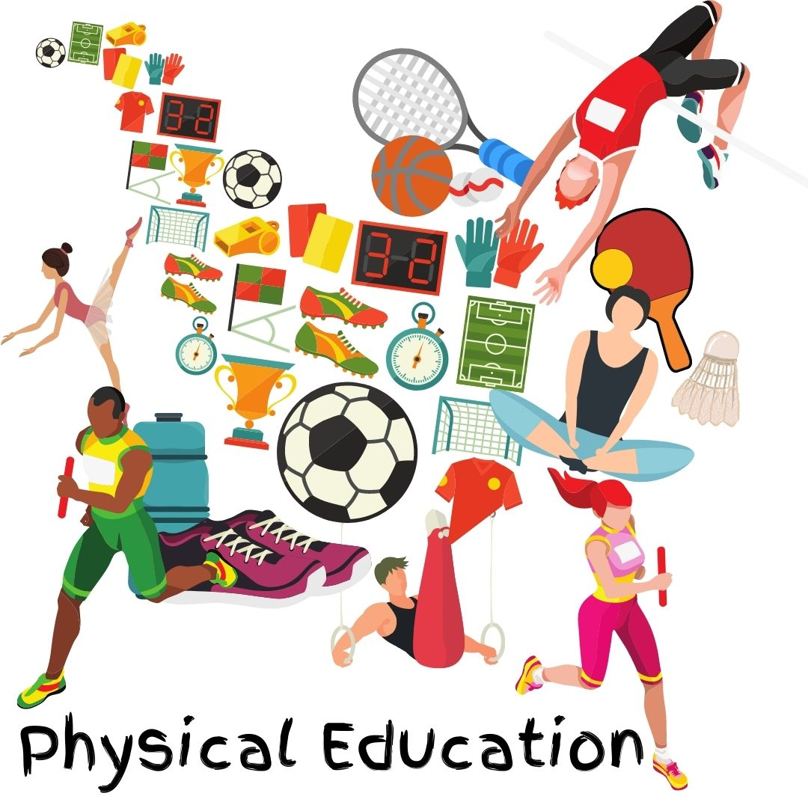



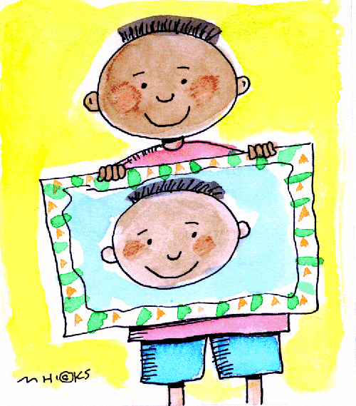

Art

The children will be developing their creative ideas and techniques through collage making, while looking at the work of Picasso!

Humanities

How did humans survive in The Savage Stone Age?

Over this term, we will be engaging in exciting activities to immerse ourselves into the Stone Age lifestyle! We will be exploring how humans survived during the Stone Age while looking at their housing, their clothing and diet.

We will also investigate where they settled, and how they progressed through to the Bronze Age, while identifying various sources of evidence.

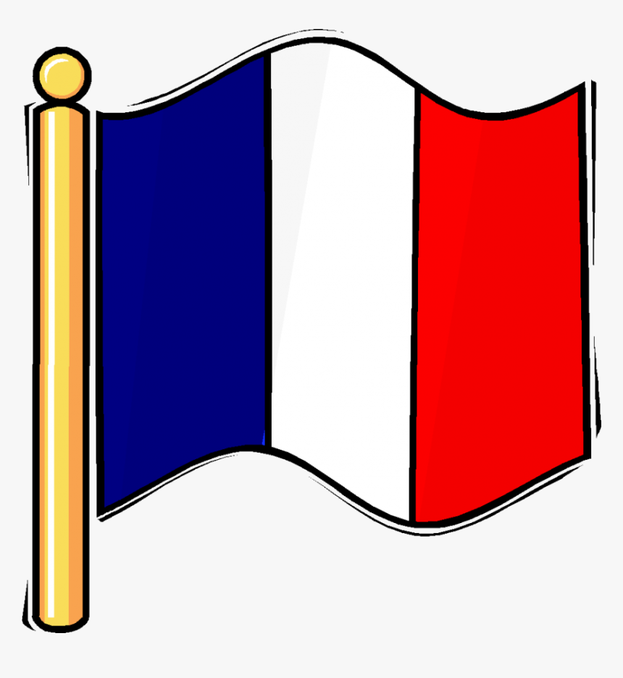

DT

We will be using our research into the Stone Age to inspire our ability to sew our own Stone Age bags!

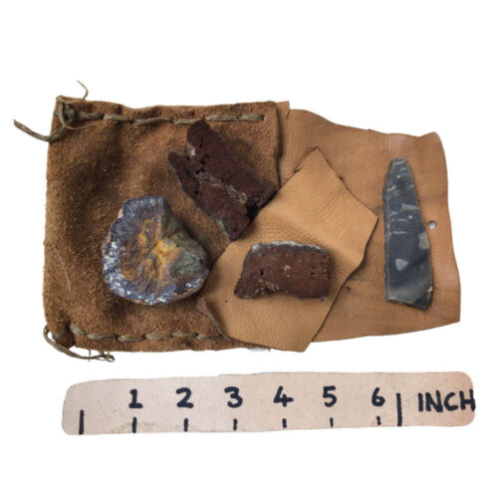

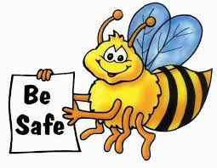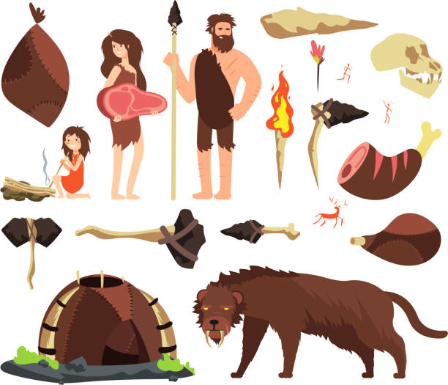



PSHE

The children will be recognising how to make informed choices. We will be understanding that people have different attitudes to risk, while recognising, predicting and assessing risks in different situations. We will look at where to get help and how to ask for help. Following this, we will be distinguishing between safe and harmful substances. This will support our overall understanding of how to keep safe.