***Egypt and the Egyptians***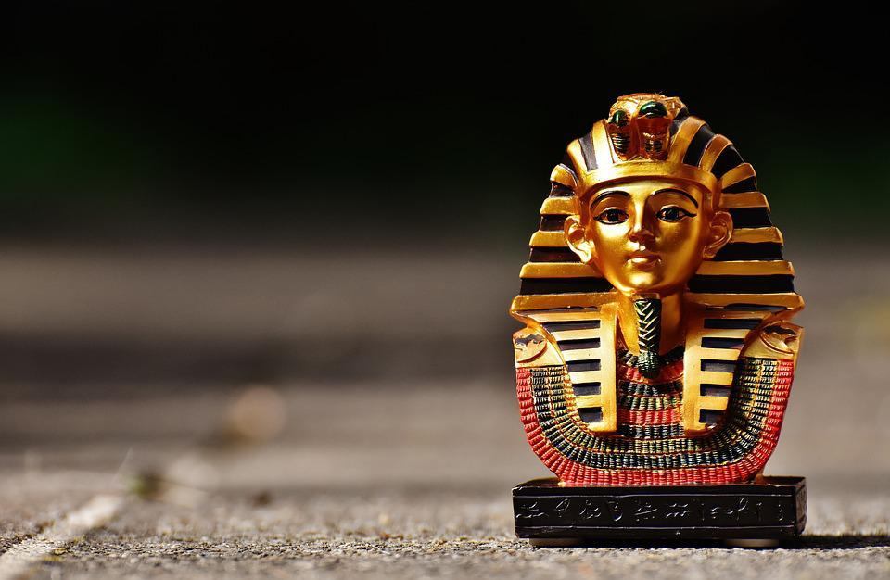

**History / Geography**

This term we are focusing on the Ancient Egyptians as well as the physical geography of Egypt and the importance of the Nile. They will answer the who, when and where of the Ancient Egyptian civilisation. We will look at maps and timelines to place Ancient Egypt in context. Children will engage with historical sources to find out clues about life in Ancient Egyptian times. Children will be given an overview of the Ancient Egyptian civilisation, focussing on the period between the time of the first pharaoh around 3100 BC to the Roman invasion in 31 BC, when Egypt became part of the Roman Empire. Children will look at the impact of notable people and events as well as broader themes of significance, achievements, chronology and legacy.

**English & Maths**

We will be following the Maths NCETM program to develop our knowledge and understanding of the four operations with an emphasis on the importance of place value. The children will also continue to develop their fluency knowledge and skills of problem solving and reasoning. Children will also look at maths in the wider world, through design, shopping, cooking and life skills like budgeting

English lessons will be cross-curricular using the topic of the Egyptians. The children will look at adventure stories, explanation texts about Egypt and the importance of the Nile as well as writing persuasive texts on the reasons to visit Egypt today.

**Science**

As scientists, the children will be looking at “Earth and Space”’ learning about the movement of the Earth, and other planets, relative to the Sun in the solar system. Children will use models and drama to describe the movement of the Moon relative to the Earth as well as describing the Sun, Earth and Moon as approximately spherical bodies that work together within our solar system. Children will use the idea of the Earth’s rotation to explain day and night and the apparent movement of the sun across the sky. They will then be given opportunities to apply their scientific knowledge of the Earth to investigate other planets.

**ICT**

This term, the children will be looking at Digital Literacy, critically evaluating websites for reliability of information/ bias and authenticity to include use of social media. They will demonstrate responsible use of online services, and know a range of ways to report concerns. Through this children will understand the impact of an individual sending or uploading unkind or inappropriate content.

**Art**

In art the children will begin by looking at and creating their own portraits using charcoal. They will also study artwork by Andy Warhol and Roy Lichtenstein, using this as inspiration to create their own pieces of art.

**RE**

Our focus this term is about the importance of identity and values, that being different is a gift. Children will explore ideas of justice and freedom as well as explore religious teaching regarding forgiveness and reconciliation.

Children will also think about the word sorry questioning whether being sorry is a word or action.

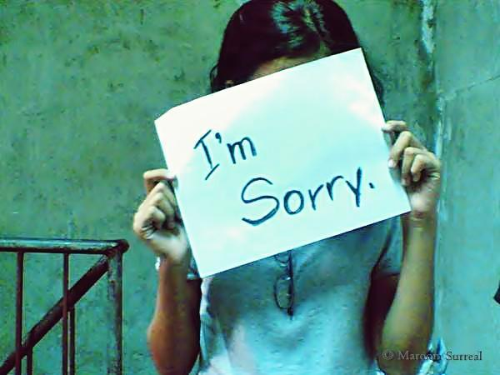

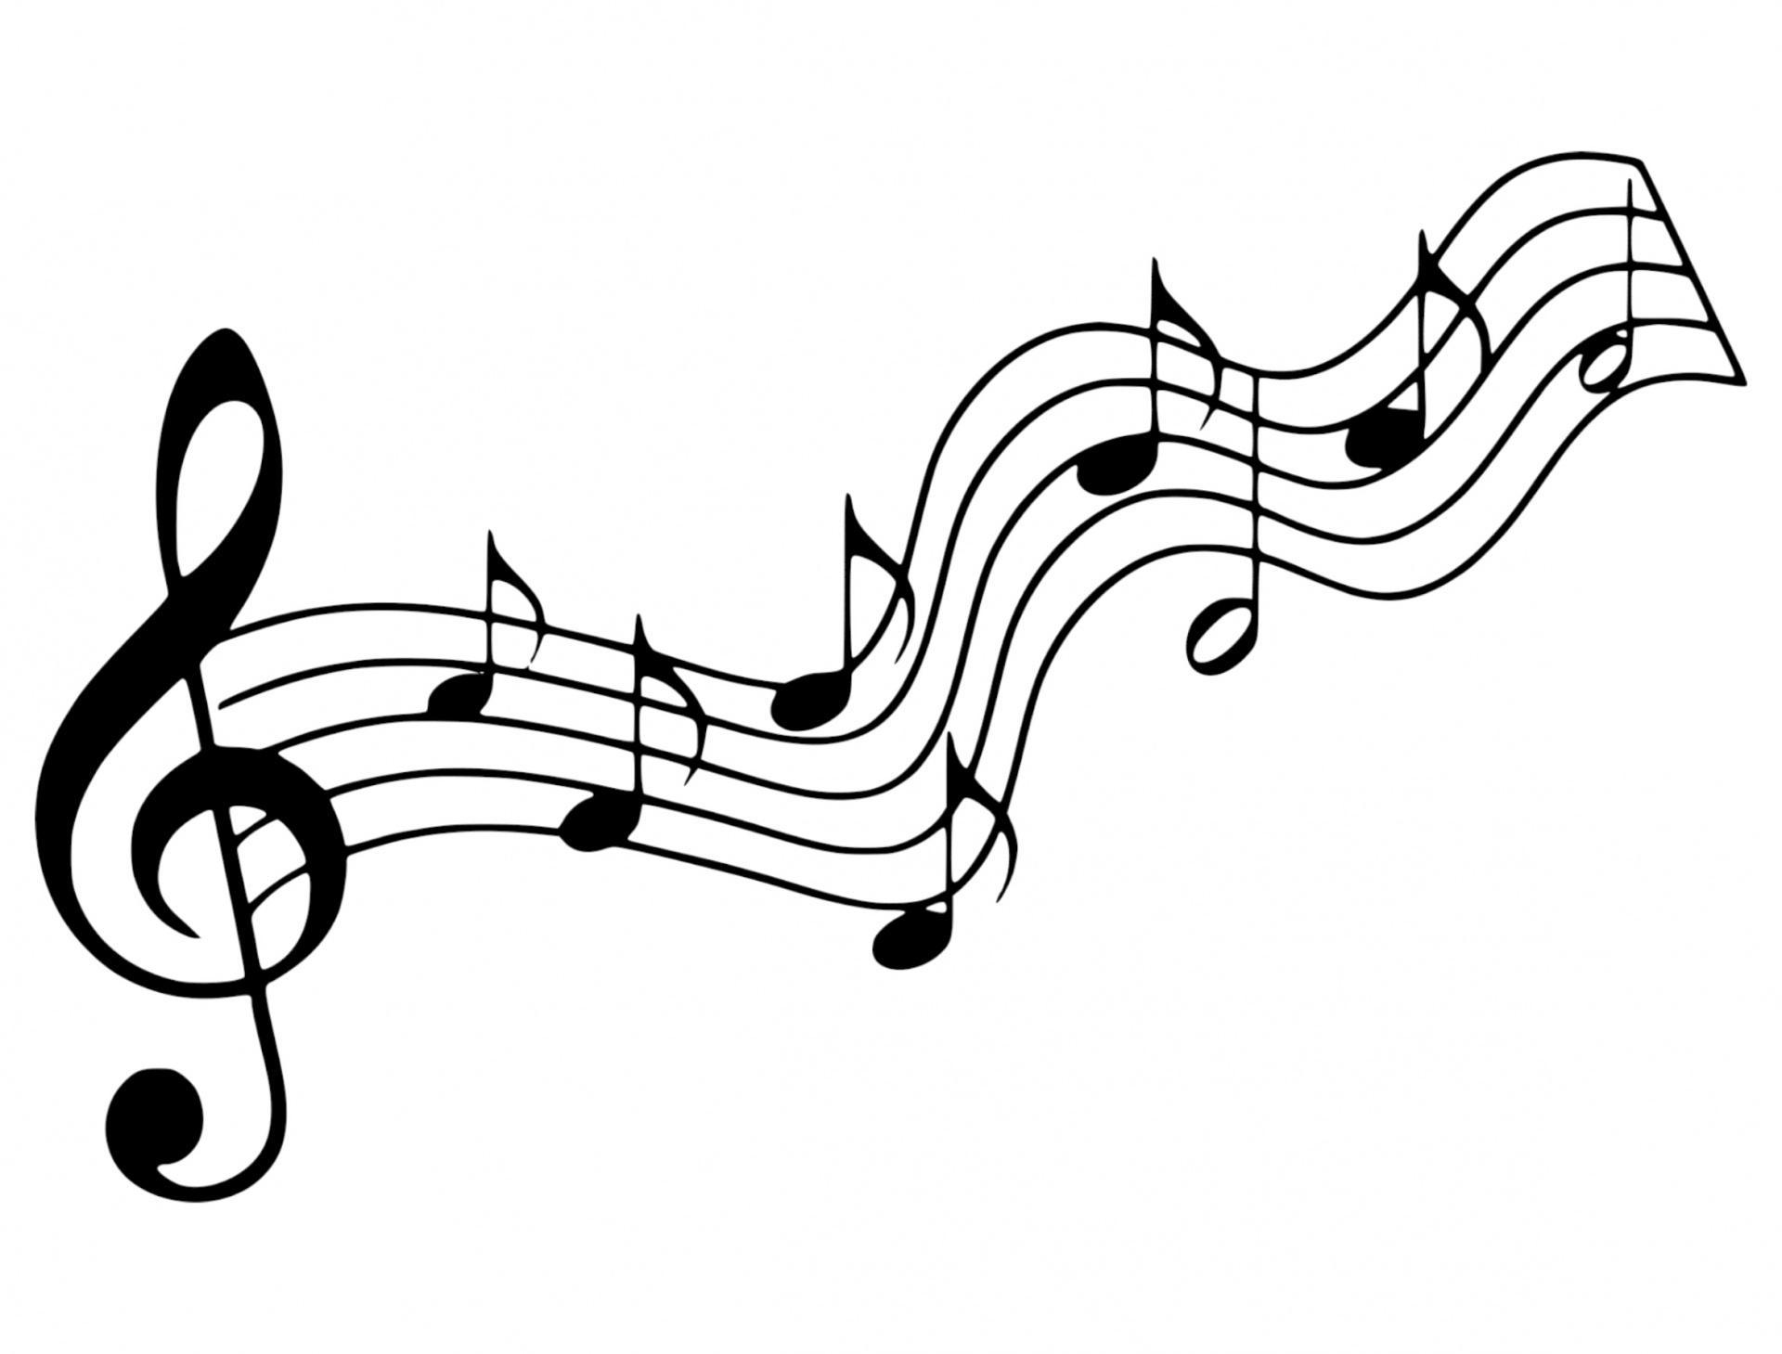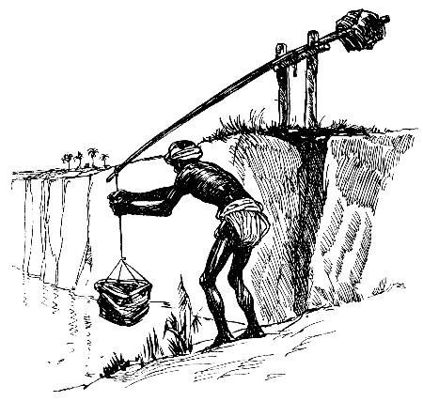

**P.S.H.C.E**

This terms focus is looking at drugs education.

They will learn how to make informed choices about health and medication, identifying a range of drugs/substances and assessing some of the risks/effects.

Children will also discuss influences and how to deal with pressure, developing skills of how to ask for help.

**DT**

Linking to our topic of the Ancient Egyptians, children will create their own shaduf by looking at pulleys and levers.

**Music**

Children will continue to work with our music specialist focussing on beat, rhythm and tempo. Children will also continue to learn how to appreciate and understand a wider range of high-quality music drawn from different traditions and from great composers and musicians. This will lead to children being encouraged to take part in their own musical class performances.