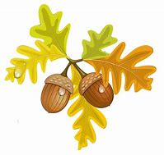
St Augustine’s Church invite you to
An Autumn Adventure
Exploring God’s creation
Wednesday 27th October 2.30pm - 4.30pm
at
Springfield Woods, Springfield House
Rise Road, Skirlaugh, HU11 5BH

Fun for all ages with
crafts, trails and food
All activities will be outdoors
so please come prepared!

Subject to weather conditions: we will go ahead in light drizzle but not in heavy rain!

Booking not necessary but to make sure there is enough food please let us know numbers to: deaconjackie23@gmail.com
All children must be accompanied by an adult

