Dear Parents/Carers, 16 September 2020

I write to let you know that the process to appoint a new headteacher for the vacant post at Sigglesthorne CE Primary Academy and Riston CE Primary Academy is well under way.

Governors and the Trust had originally planned to interview candidates in early April but – as I’m sure you can appreciate – the process needed to be stalled in view of the Covid 19 situation. As our schools are now once again fully open to all pupils, we are in a position to go ahead with the task of finding the right headteacher to drive the schools forward on their collective journey. To this end interviews will be held on 22 and 23 September 2020 at Riston and the following day at an Ebor venue in York. The candidates will visit Sigglesthorne as part of the process on 22 September but after the children have finished their school day.

The candidates and interview panel will be in the building at Riston on 22 September and will work with with the children maintaining social distancing (2m minimum at all times) and wearing PPE where guidance dictates it. They will not spend any longer than 15 minutes of interaction with any children and a full risk assessment has been completed for the process.

Should you not wish your child to be part of our plans to select the new headteacher by interacting with visiting adults, then please let the school know by 9.00 on 21 September.

We will keep you informed of our progress on the new appointment.

Yours sincerely,

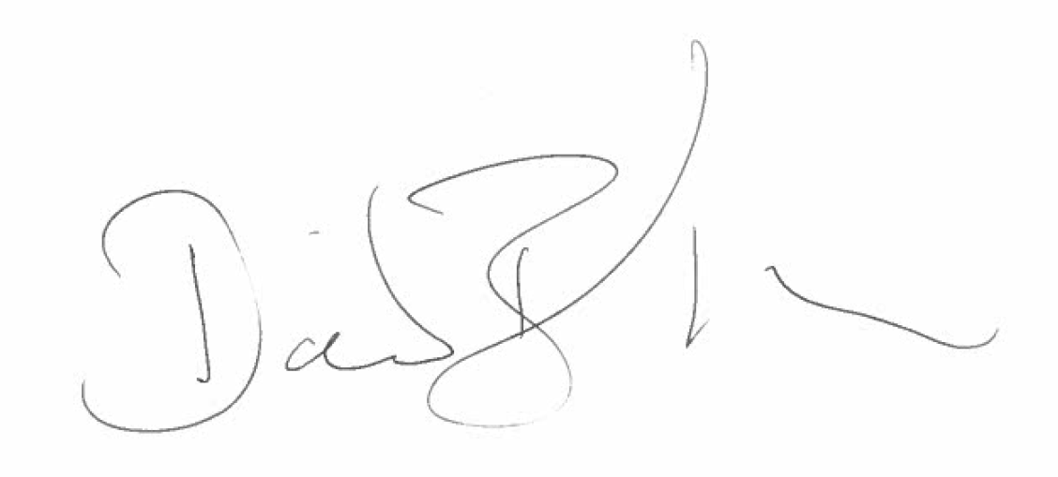

Dave Barber – Ebor Executive Headteacher

