9 October 2019

Parents and carers
Riston Church of England Primary Academy,
Sigglesthorne Church of England Primary Academy

Dear parent/carer,

I am writing to advise you that Mrs Hall, headteacher at both Riston and Sigglesthorne schools, will be leaving us in February next year to take up the Headship at Hilderthorpe Primary School, Bridlington. I’m sure you will join us in wishing Mrs Hall the very best for the future and in thanking her for her commitment to the children at our schools. As you know, she is a very effective headteacher and I’m sure she will relish the challenges that her new post will bring.

In consultation with the executive team, governors and trustees we have made plans to place a senior leader currently working in the trust in post as interim headteacher across Riston and Sigglesthorne from 24 February 2020 until 31 August 2020. During this period the headship across the schools will be advertised, with the intention that a candidate will be appointed to begin work on 1 September 2020.

I will be in touch soon with the name of the interim head in the near future. There will be an extensive transition plan put in place running up to February and parents will be given the chance to meet the interim head in due course.

Additional school support will be provided by our Ebor School Improvement team until the end of the school year.

Thank you for your continued support of our schools.

Yours faithfully,

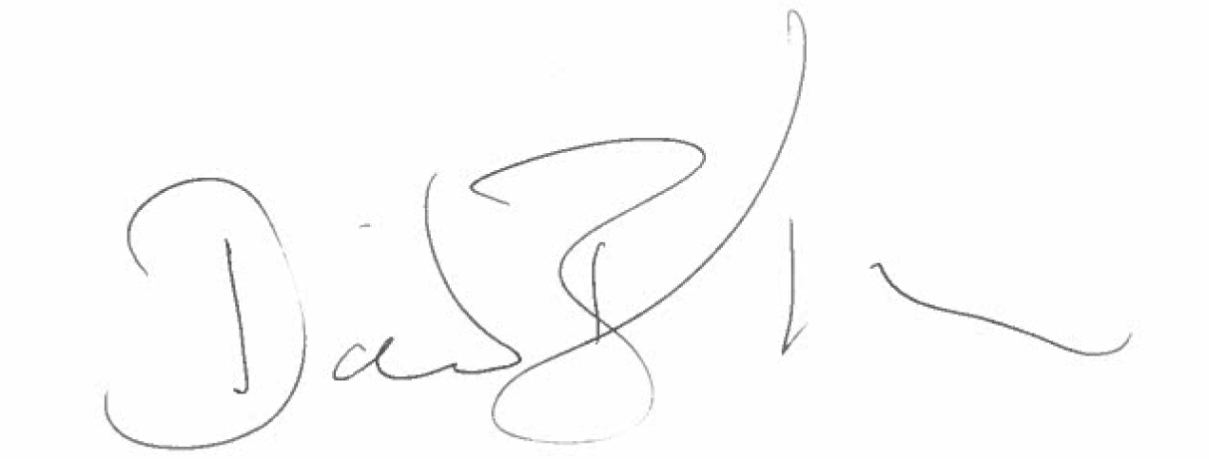

Mr D Barber
Executive Headteacher

