Dear Parent/carer
As you are aware Global learning is very important to us at Sigglesthorne. We are launching our Global Goals by joining the World Largest Lesson with our partner school, Redemption Academy Wisdom Primary in Sierra Leone on Thursday March 28th. Joining us on this journey are Riston and Skirlaugh Primary, along with their partners Wisdom Primary and Lillian Prep in Sierra Leone. This is quite a venture for our 6 schools to embark on together.
The first of the 17 goals for sustainable living that we are working on is goal 6, clean water and sanitation. All 6 schools will be delivering the same learning and lessons on the same day! A group of children from our school will be joining Children from Skirlaugh at Riston School for a morning of global exploration. Whilst our partners in Sierra Leone do the same.
In connection with our work on goal 6, clean water and sanitation, we will be working on goal 10, reduced inequality. Our letters and correspondence with our partner schools has led us all to consider the inequalities in our world. We hope that together with our local schools, and schools in Sierra Leone, that we can raise money and awareness that will help to support them with their goal of achieving clean water and sanitation. Something that we often take for granted. To achieve this goal we will be completing a sponsored water carry!
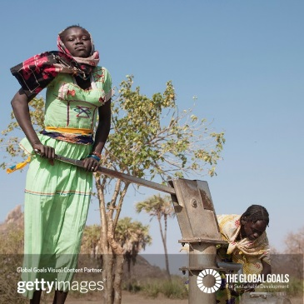
All the children at Sigglesthorne, Riston and Skirlaugh we will be carrying water to represent the journey made every day by our partners in Sierra Leone to get clean water from their local wells. We will be counting up the laps we cover to try and estimate a distance and time spent as a team at the end of the day. Please gather as many sponsors as you can and help us to make a difference. We are aiming to keep the water moving for 6 hours and we will work in teams to achieve this!
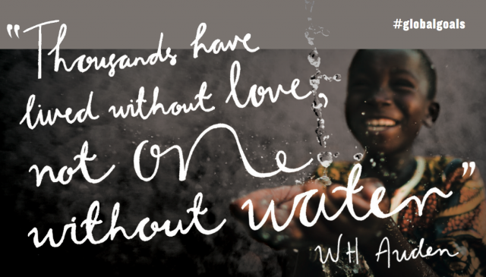
We hope you are able to support us in making a difference. You can see the global goals and access family activities for yourself at http://worldslargestlesson.globalgoals.org/
Many thanks,
Mrs Grant

Sponsor Form – World Largest Lesson
Goal 6 – Clean Water and Sanitation
Child’s name:

The BIG water carry
– Thursday 28th March

Name | Amount (per hour or in total) | Total
Total amount

